- SOHO NETWORK SETUP ASSIGNMENT
Q1. SOHO Network Diagram
The following diagram shows one broadband internet connection connected to a Wi-Fi router. The two laptops use wireless Wi-Fi, while the smart TV and printer are shown using wired Ethernet connections for stable connectivity.
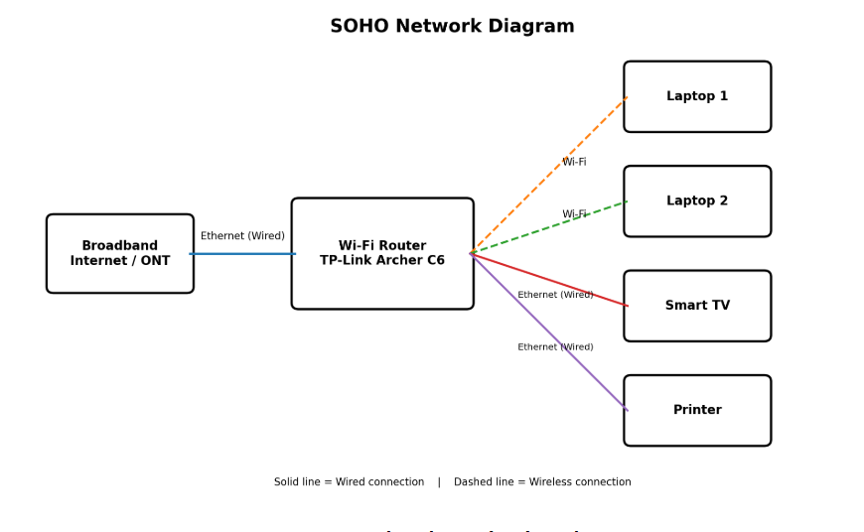
Q2. Hardware Components Required
The following are practical examples of hardware that can be used to build this network. Models are suggestions only; equivalent devices can also be used. Current listings can change in price and availability.
Component | Suggested Brand / Model | Qty. | Purpose
Broadband connection / ONT | ISP-provided fiber ONT/modem (JioFiber, Airtel Xstream, BSNL FTTH, etc.) | 1 | Provides internet connection to the router.
Wi-Fi router | TP-Link Archer C6 AC1200 Dual-Band Gigabit Router | 1 | Shares internet through Wi-Fi and Ethernet.
Laptops | Any Wi-Fi capable laptop, e.g. Lenovo IdeaPad / HP 15 series | 2 | Wireless client devices for office/home work.
Smart TV | Any Wi-Fi/Ethernet smart TV, e.g. Samsung/LG/Xiaomi | 1 | Streaming and smart applications.
Printer | Wi-Fi/Ethernet network printer, e.g. HP LaserJet MFP M233dw | 1 | Shared printing over the network.
Cat6 Ethernet cable | Portronics / FEDUS / D-Link Cat6 RJ-45 cable | 3 | ONT-to-router, router-to-TV and router-to-printer links.
RJ-45 connectors | D-Link / FEDUS Cat6 compatible RJ-45 | As needed | Used if making custom Ethernet cables.
Power strip / surge protector | Belkin / GM / equivalent | 1 | Safely powers router, ONT and other devices.
Optional Gigabit switch | TP-Link TL-SG1005D 5-Port Gigabit Switch | 1 (optional) | Adds Ethernet ports if the router does not have enough LAN ports.
Optional Wi-Fi extender | TP-Link TL-WA850RE | 1 (optional) | Extends Wi-Fi coverage in a larger home/office.
Reference note: A recent Flipkart listing for the TP-Link Archer C6 shows dual-band 2.4/5 GHz Wi-Fi, 1200 Mbps wireless speed, Gigabit LAN/WAN, four LAN ports and one WAN port. Flipkart also lists the TP-Link TL-WA850RE as a 300 Mbps range extender. Prices and stock should be checked again before purchase.

Q3. Step-by-Step Wi-Fi Router Configuration
Connect the broadband ONT/modem to the router WAN/Internet port using an Ethernet cable. Switch on the ONT and router.
Connect a laptop to the router using Wi-Fi or a LAN cable.
Open a web browser and enter the router management address. Common examples are 192.168.0.1 or 192.168.1.1; use the address printed on the router label/manual.
Log in with the router administrator credentials. During first setup, many routers ask you to create an administrator password.
Open Internet/WAN settings and select the connection type required by the ISP, such as Dynamic IP (DHCP) or PPPoE. Enter ISP username/password only if the ISP provided them.
Open Wireless/Wi-Fi settings and change the default network name (SSID). Example SSID: SOHO_Office_WiFi.
Under Wireless Security, select WPA2-Personal/WPA2-PSK with AES. If the router supports WPA2/WPA3 mixed mode and all devices support it, that may also be used.
Create a strong Wi-Fi password, for example a long unique password containing uppercase/lowercase letters, numbers and symbols. Do not use the example password in a real network.
Open Administration/System settings and change the default router admin password to a different strong password from the Wi-Fi password.
Enable DHCP Server for normal client devices. Example DHCP range: 192.168.1.100 to 192.168.1.200.
Save/apply the settings. The router may restart. Reconnect both laptops using the new SSID and Wi-Fi password.
Test internet access by opening a website and confirm that the smart TV and printer are reachable on the local network.
Screenshot space (optional): Router wireless/security settings
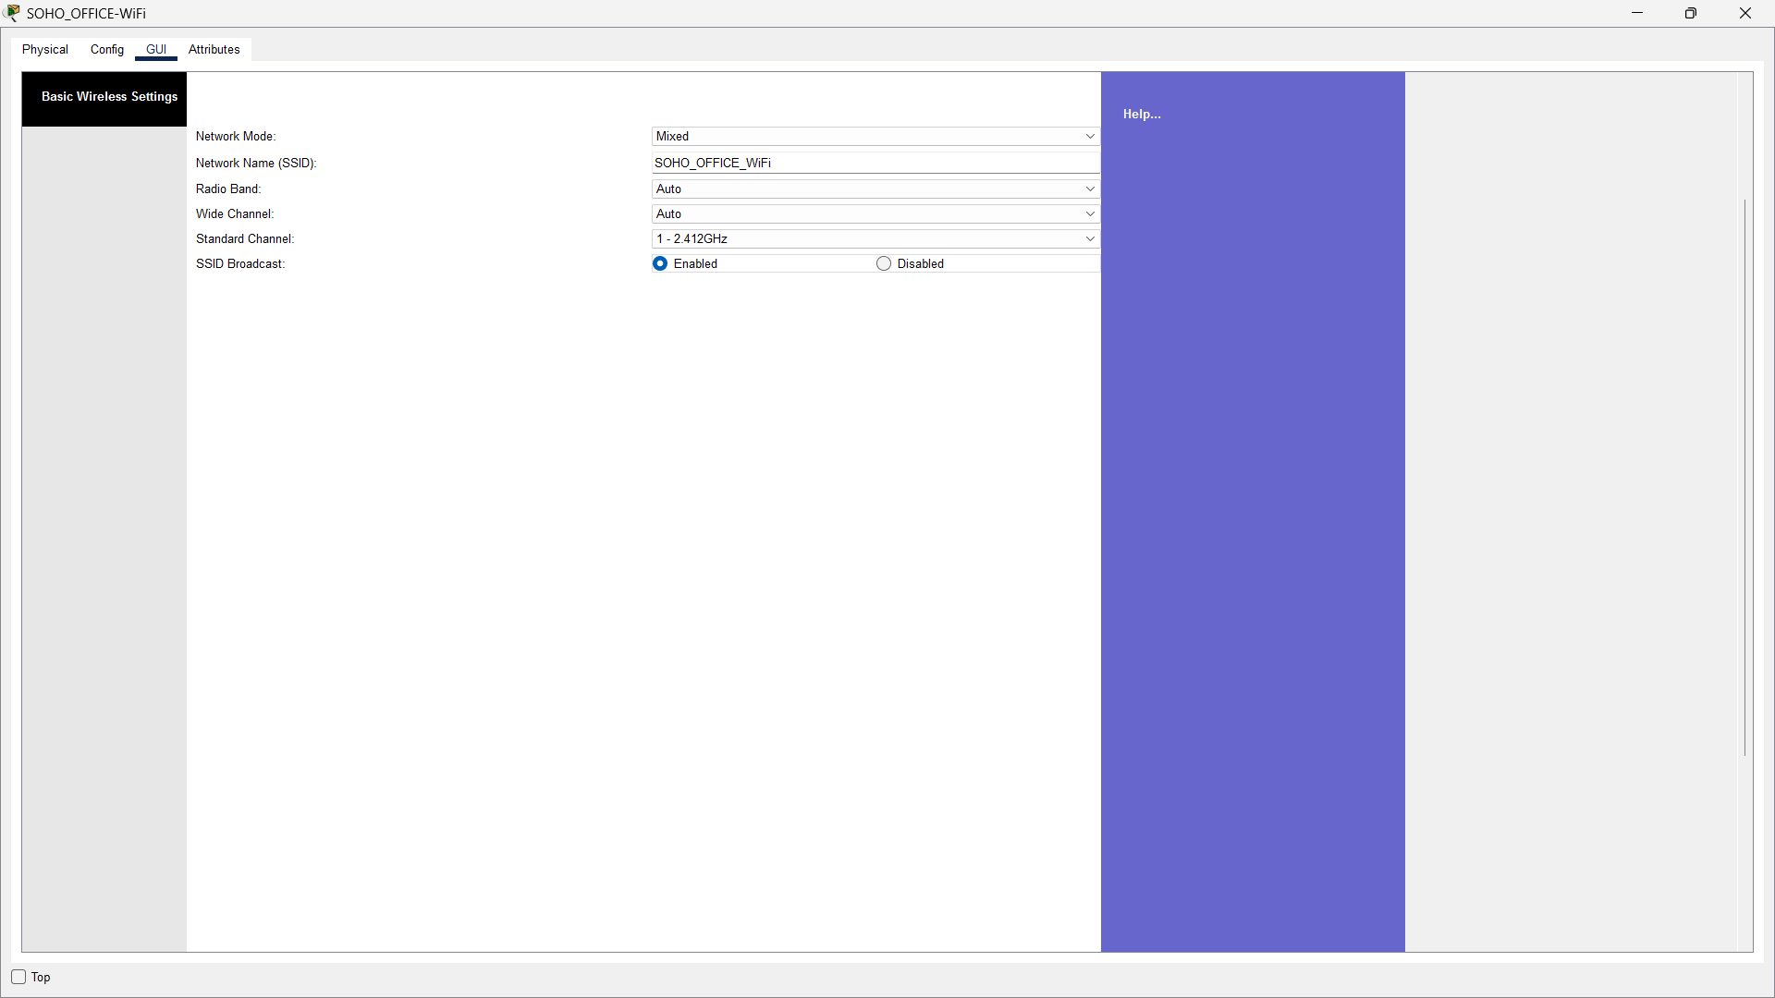
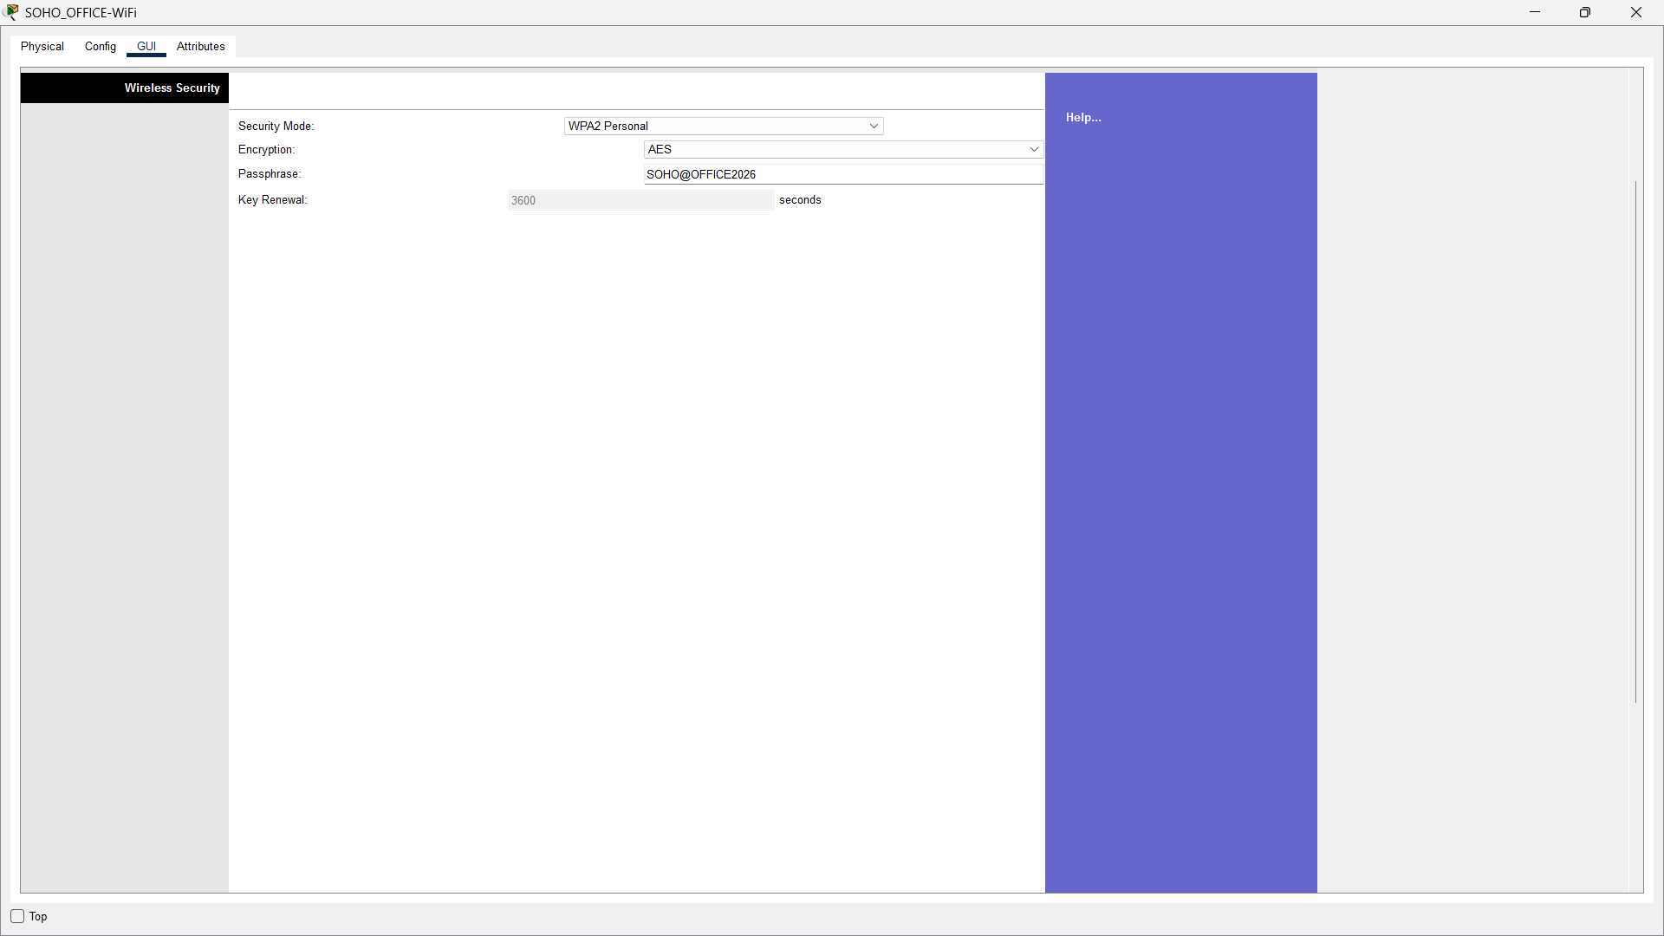
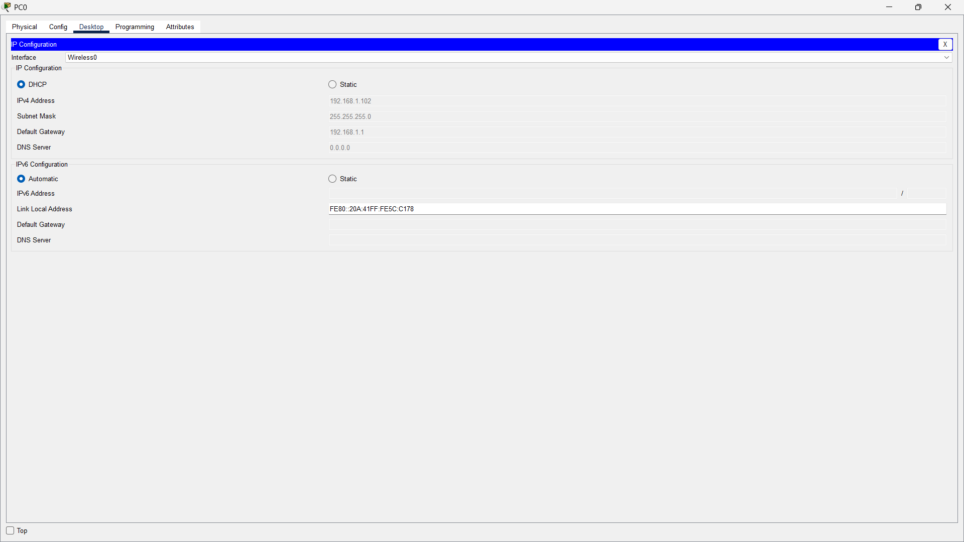
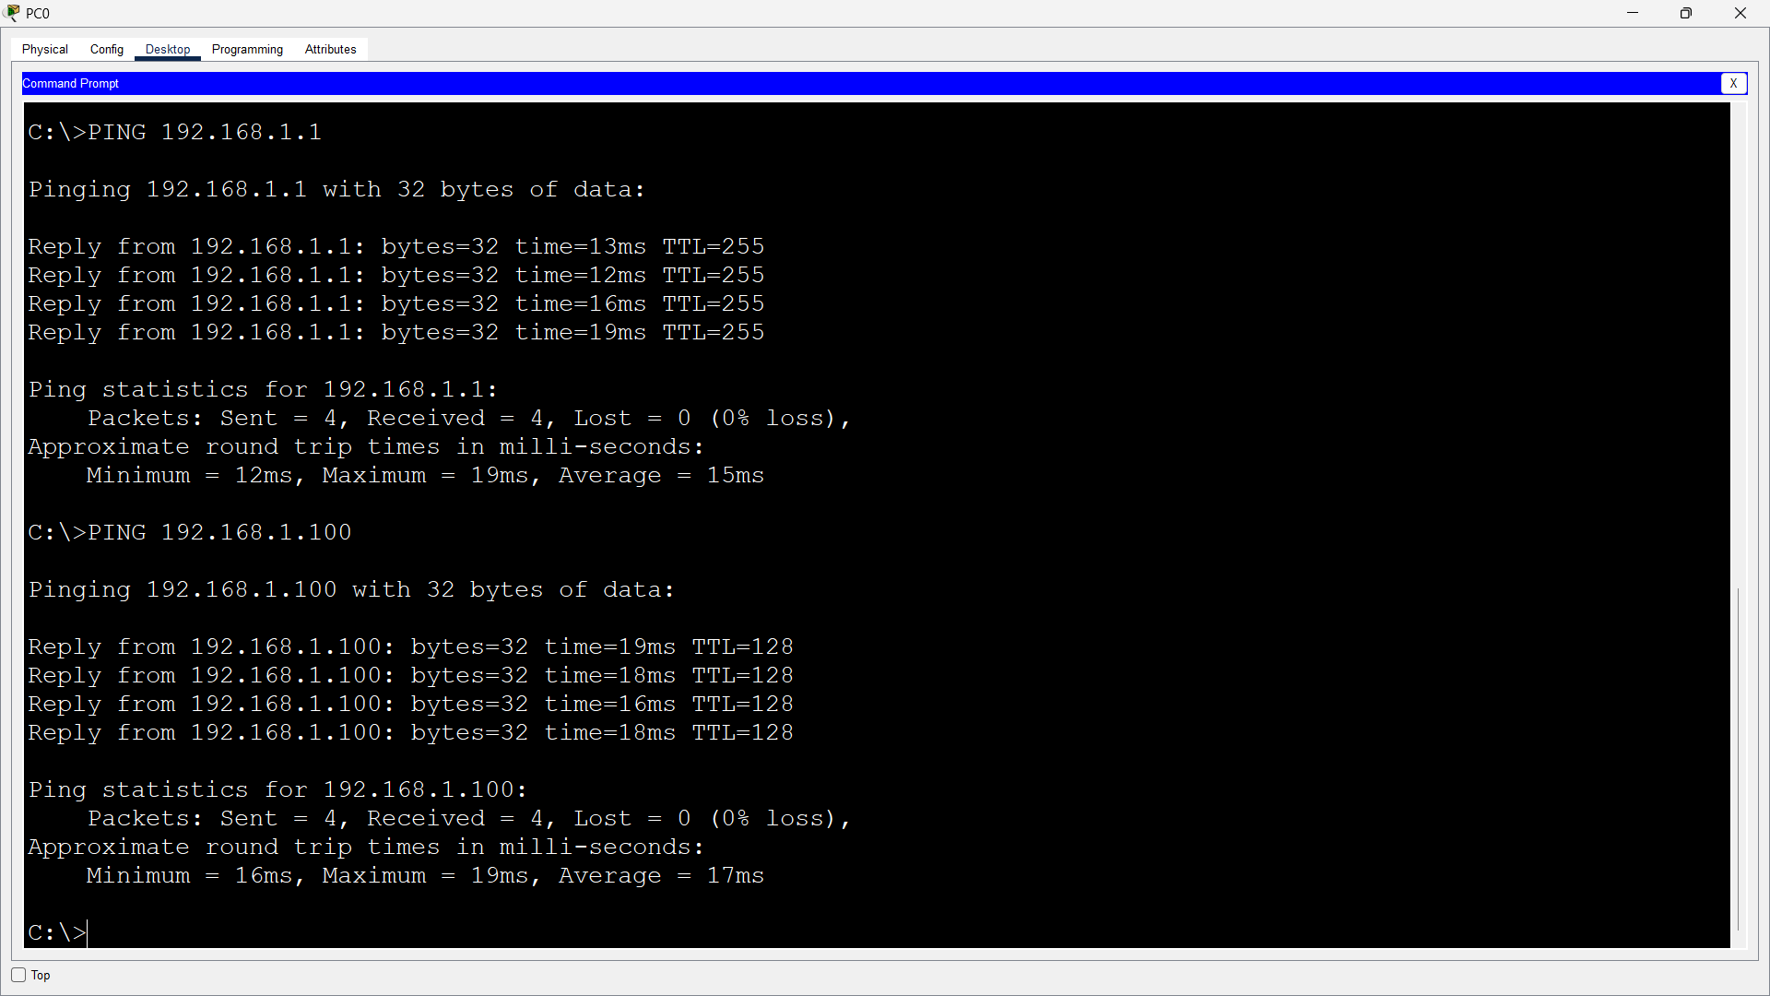

Q4. IP Address Configuration
Example LAN network: 192.168.1.0/24 | Subnet Mask: 255.255.255.0 | Router/Default Gateway: 192.168.1.1 | DNS: 192.168.1.1 or ISP/public DNS.
The printer and smart TV use static IP addresses outside the example DHCP pool. The laptops receive their addresses automatically from DHCP. The MAC addresses below are made-up locally administered examples for this assignment.
Device | Connection | MAC Address (Example) | IP Method | Assigned IP
Wi-Fi Router (LAN) | Wired/Wireless gateway | 02:10:20:30:40:01 | Static | 192.168.1.1
Printer | Wired Ethernet | 02:10:20:30:40:10 | Static | 192.168.1.10
Smart TV | Wired Ethernet | 02:10:20:30:40:20 | Static | 192.168.1.20
Laptop 1 | Wi-Fi | 02:10:20:30:40:31 | DHCP | 192.168.1.101 (example lease)
Laptop 2 | Wi-Fi | 02:10:20:30:40:32 | DHCP | 192.168.1.102 (example lease)
Important: Static addresses should not overlap the DHCP pool. In this example, static devices use low addresses (.10 and .20), while DHCP starts from .100.
Q5. Troubleshooting: Laptop Cannot Connect to the Internet
Possible Cause | How to Diagnose | How to Fix
1. Wi-Fi is off, airplane mode is on, or wrong SSID/password | Check the Wi-Fi icon. Confirm the laptop is connected to SOHO_Office_WiFi and not another network. | Turn off airplane mode, enable Wi-Fi, forget the wrong network if needed, and reconnect using the correct password.
2. Laptop did not receive a valid DHCP address | In Windows, run ipconfig. If the address is 169.254.x.x or no default gateway appears, DHCP may have failed. | Reconnect Wi-Fi, run ipconfig /release and ipconfig /renew, and check that DHCP Server is enabled on the router.
3. Router or broadband/ISP connection is down | Check whether the second laptop/TV can access the internet. Check router Internet/WAN light and ONT indicators. | Restart ONT and router. Check the WAN Ethernet cable. If all devices are offline, contact the ISP if the WAN service remains down.
4. Weak Wi-Fi signal or interference | Move the laptop closer to the router and check whether connectivity improves. | Place router in a central open location, try the other Wi-Fi band, or use an extender/access point if coverage is poor.
5. DNS problem | Ping the router first. If local connectivity works but websites do not open, test name resolution with nslookup. | Restart the network connection/router or use a known DNS service according to network policy.
6. Network adapter/driver problem | Open Device Manager and check the Wi-Fi adapter for errors. | Disable/enable the adapter, update/reinstall the Wi-Fi driver, then restart the laptop.
Basic Diagnostic Order
Check Wi-Fi connection and signal.
Check IP address using ipconfig.
Ping the default gateway: ping 192.168.1.1.
Test another device on the same network.
Restart laptop/router/ONT if necessary.
If all devices fail, check ISP service; if only one laptop fails, focus on that laptop's Wi-Fi adapter, DHCP, DNS and firewall settings.
Conclusion
A SOHO network can be built with a broadband connection, a Wi-Fi router and a small number of wired/wireless client devices. Correct Wi-Fi security, IP planning and basic troubleshooting make the network reliable and safer for everyday home or small-office use.

